Computer Programming Using Kivy 1.9.0 for Python 3 - **Canvas 3 - Text**

GOAL: Create a debug screen by adding Text code to the touch event to make the program show information about the event.

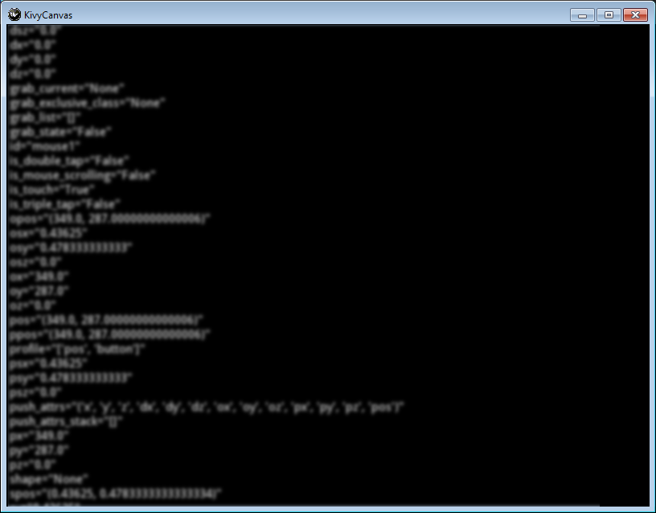

* Open Geany, File, Open, Computer, Resources R:\Classes\ComputerProgramming\Examples\kivyCanvas.py

(R:\Classes\ComputerProgramming\Examples\kivyCanvas.py)

* File, Save As, your home drive (such as T:*username or H:*), then name it canvas3text.py
* To use text in Kivy, you need a label. First import label so you can use it anywhere after you import Kivy (the folder is named with lowercase ‘k’) but before the classes which may need it are written:

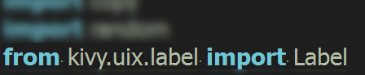

* Indented under class CanvasForm, create a Label variable & canvasTouchDown method that will show information about the event:

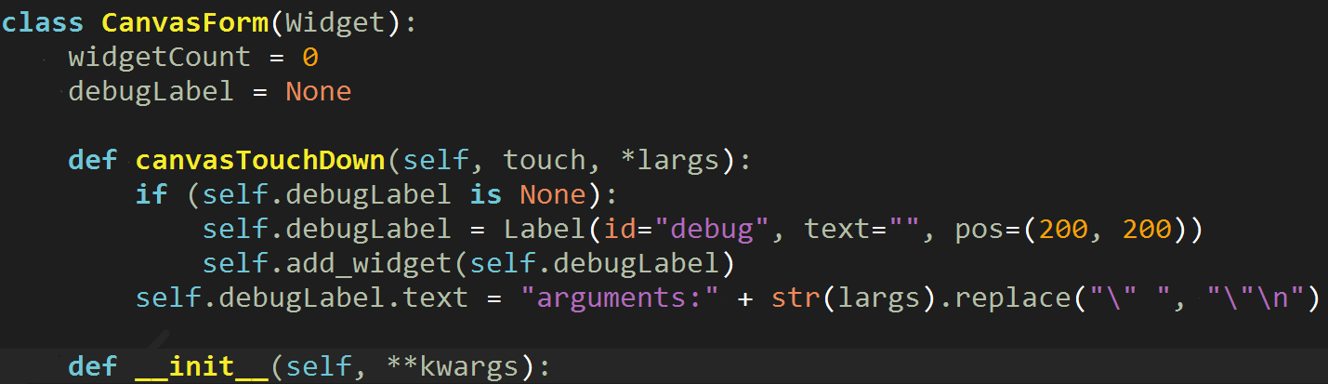

* Next, inside of the CanvasForm __init__ method, where all events are bound to methods, bind your canvasTouchDown method to the touch down event so it becomes the handler for that event (so canvasTouchDown is called each time you touch the canvas):

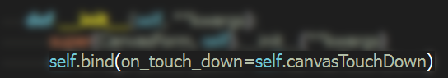

* Try removing:
  + .replace("\" ", "\"\n")
  + Then run the program and click anywhere. Kivy will put all of those variables from the event on one line.
  + Put that code back after you try running it, so you know why that is helpful.
* Click Execute and make sure you can click and see all the information about the click event like in the picture at the top of this page.

|  |
| --- |
| TIP:  If you want to use those any of those variables listed in one of your programs, you can use the first index of largs which is zero, then a dot, then the variable, such as:    BONUS: use this to make your program do something different (other than what text to display) depending on is_double_tap or any other variable in the touch event. |